

**Name：[AZHAR Ali]**

**CMS：[023-23-0314]**

**SEC：[A]**

**DSA LAB**

1. 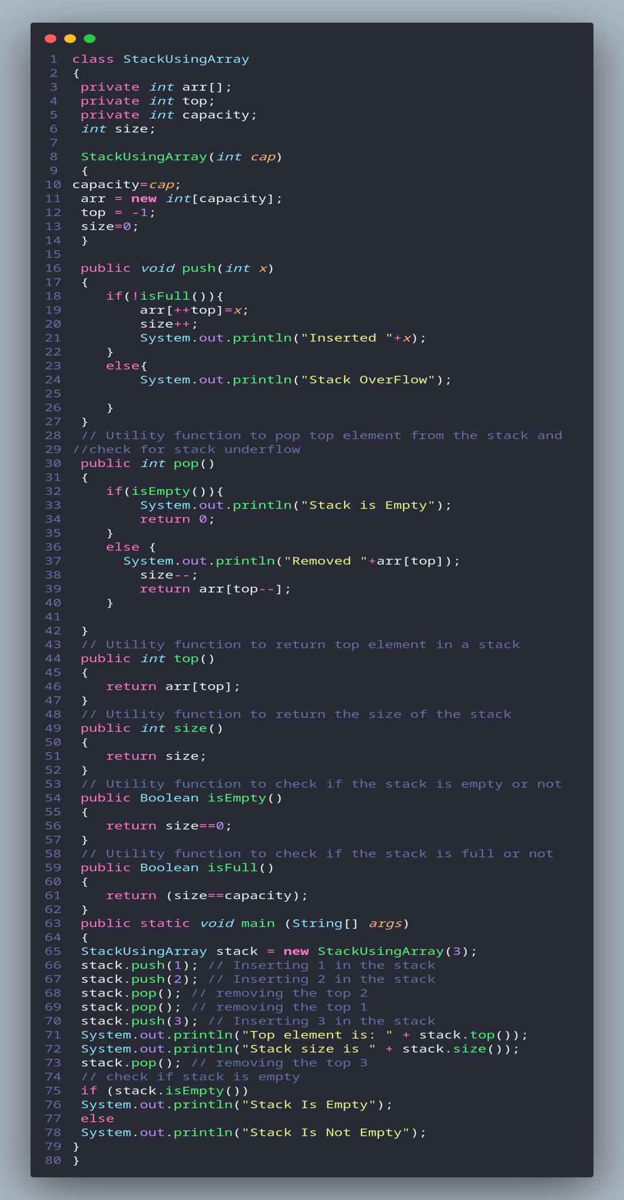**Stack using array**: Understand provided code and implement all required   
   methods in Stack. Stack Code is given below:

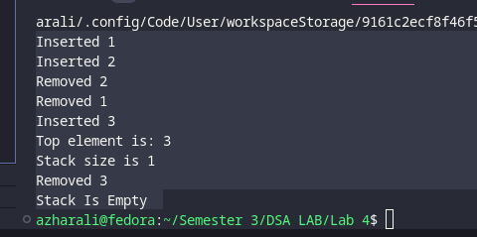

1. **Stack using Linked list**: Understand provided code and implement all required   
   methods in Stack. Stack Code is given below:

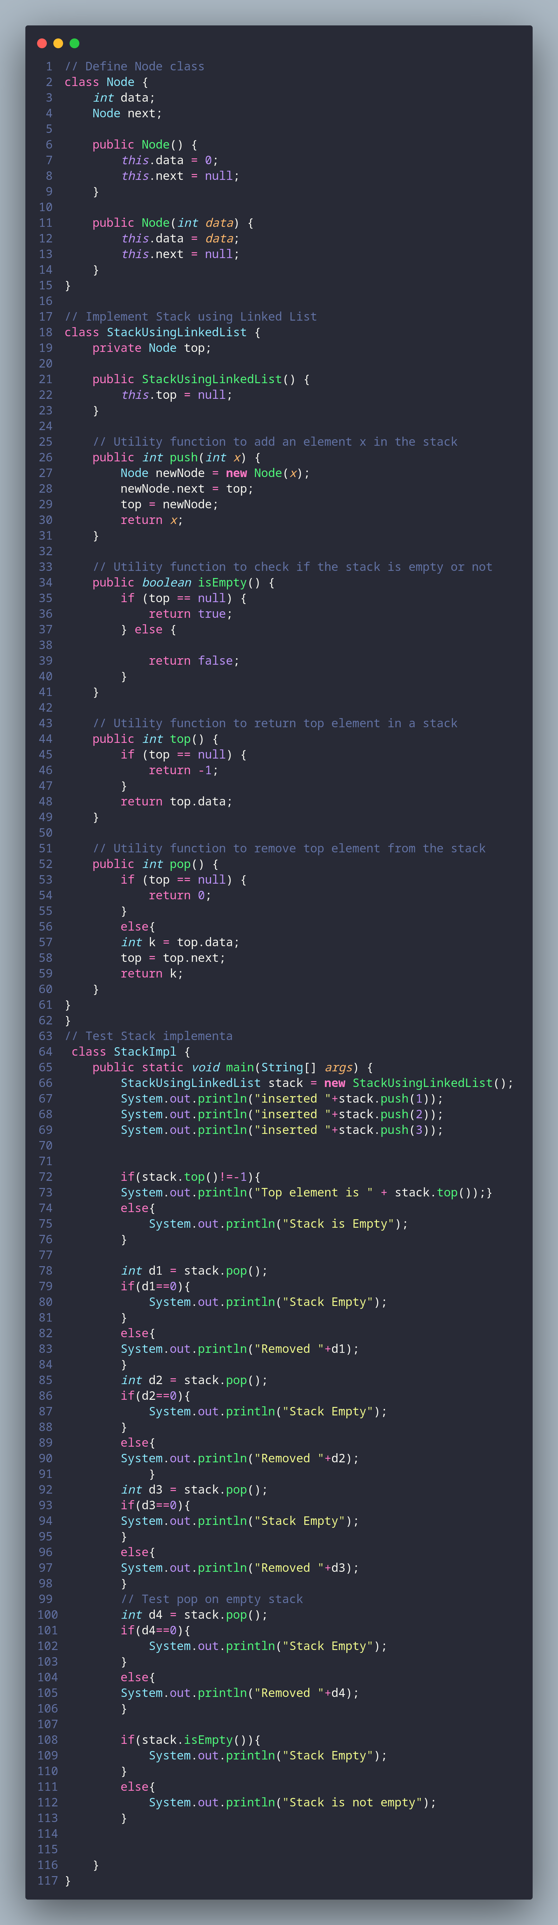

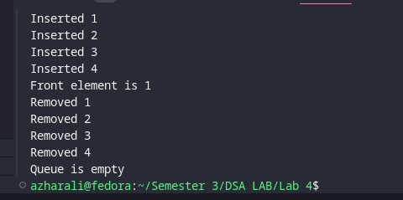

1. **Queue using array**: Understand provided code and implement all required   
   methods in Queue. Queue Code is given below:

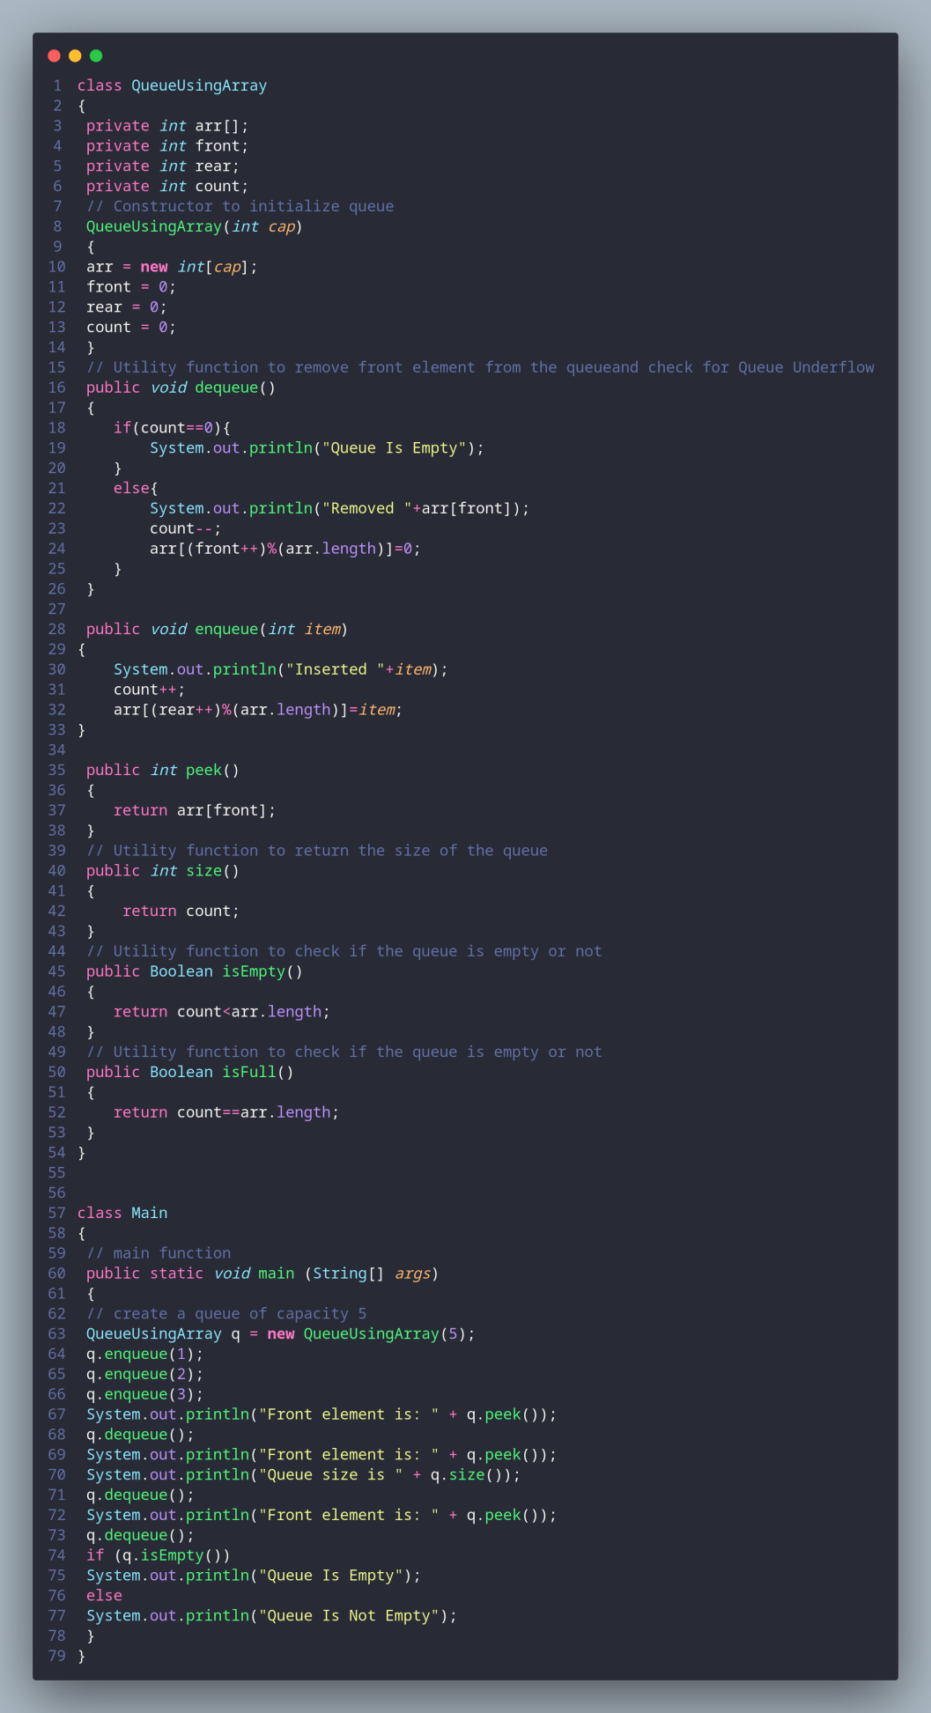

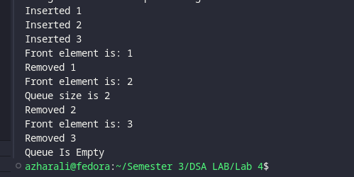

1. **Queue using Linked list**: Understand provided code and implement all required   
   methods in Queue. Queue Code is given below:
2. 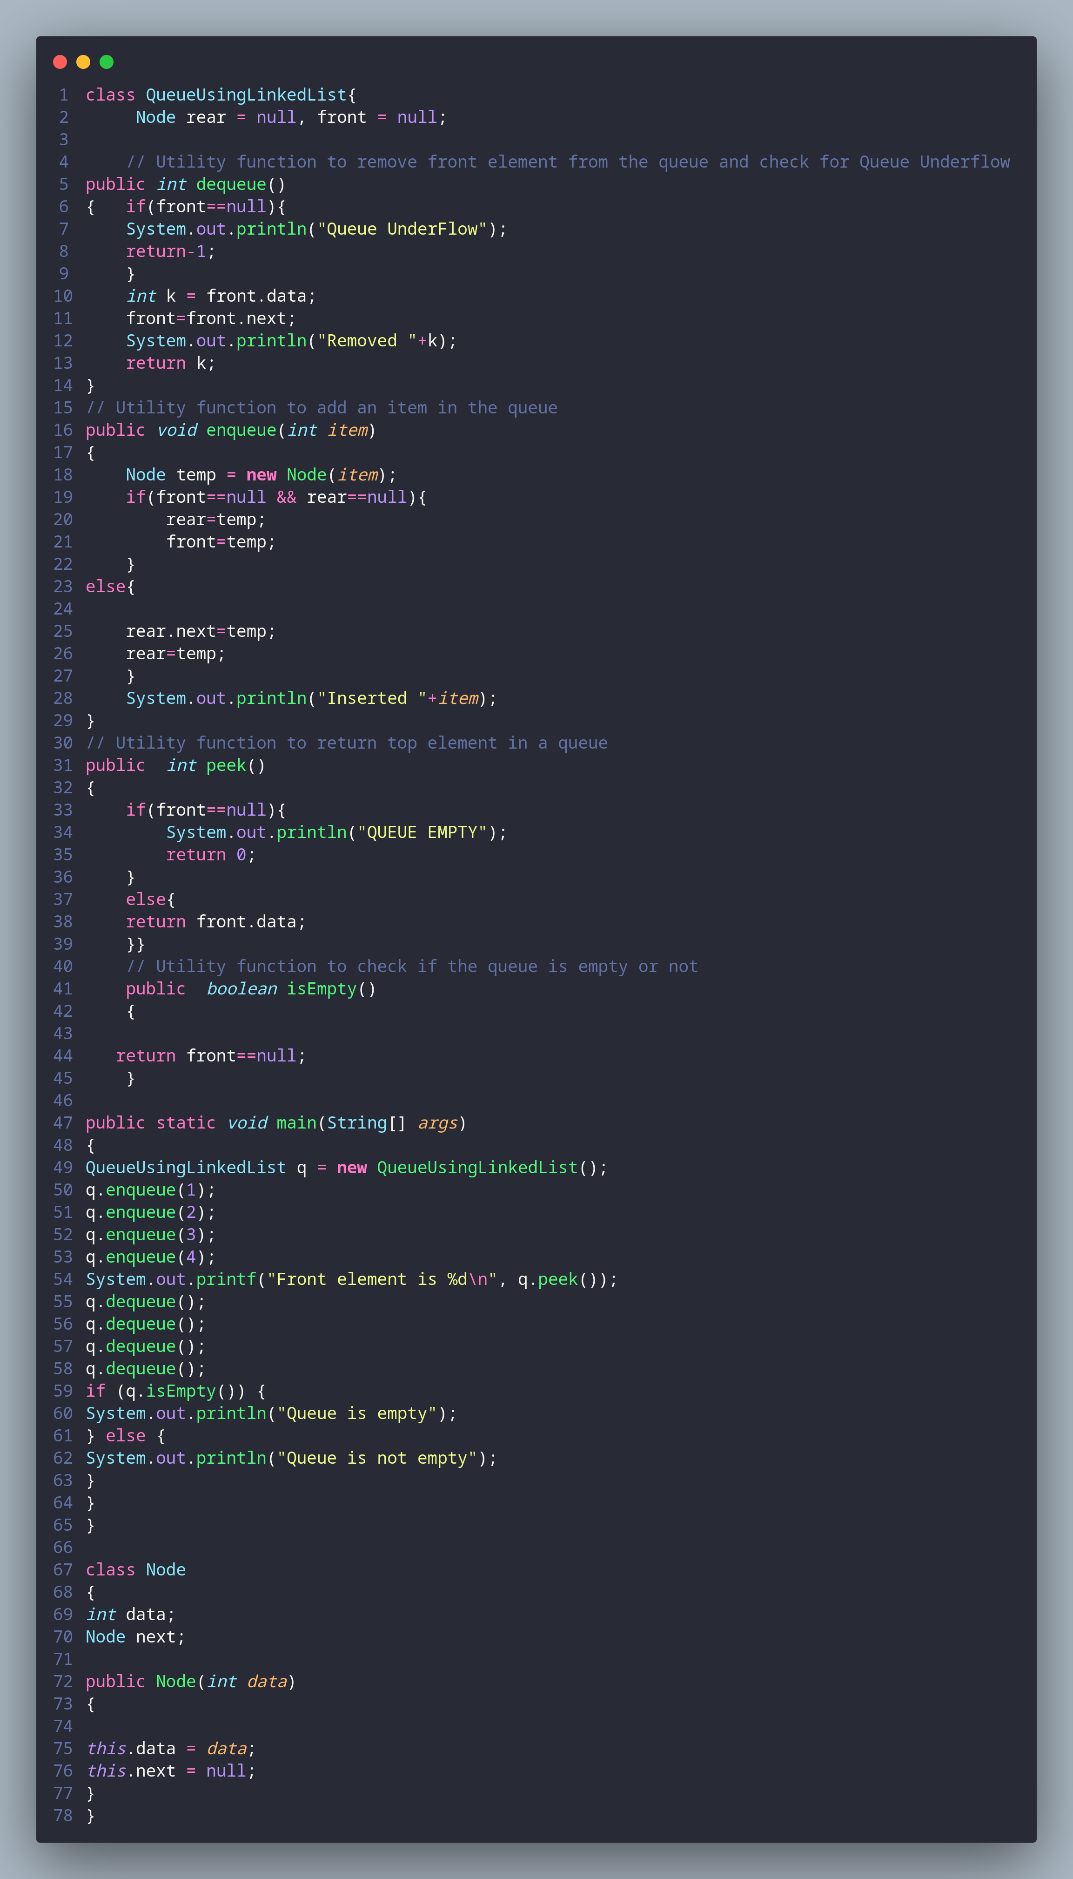**Queue using two Stacks**: Understand provided code and implement all required methods in Queue Class. Sample Code is given below:

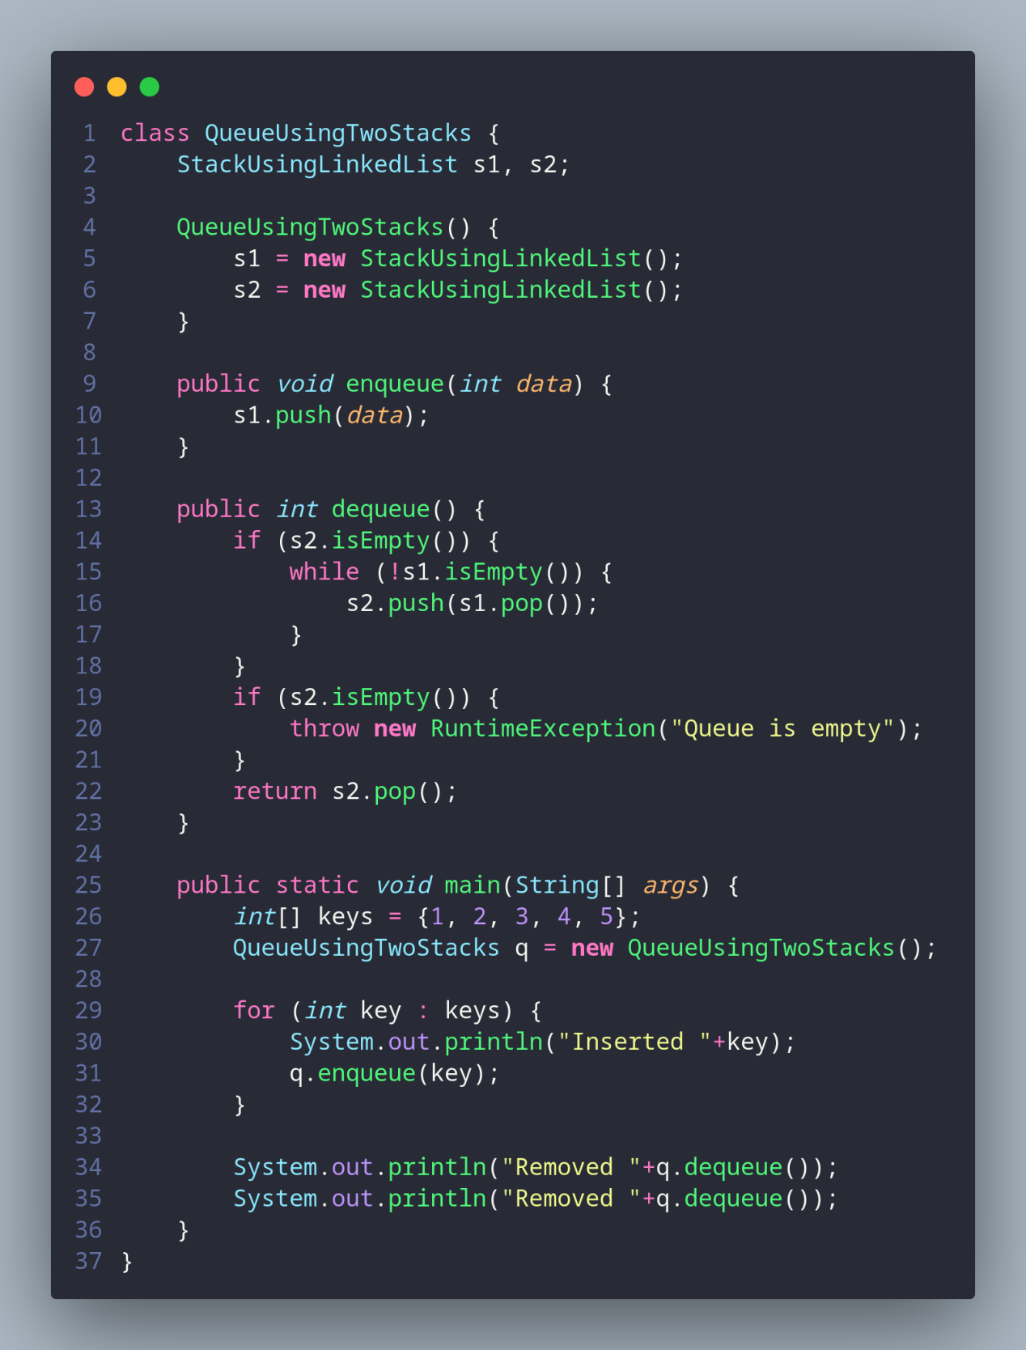

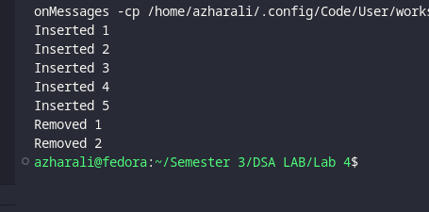

1. think about the inverse of task 05 (Stack using queue) and implement all the required methods.

